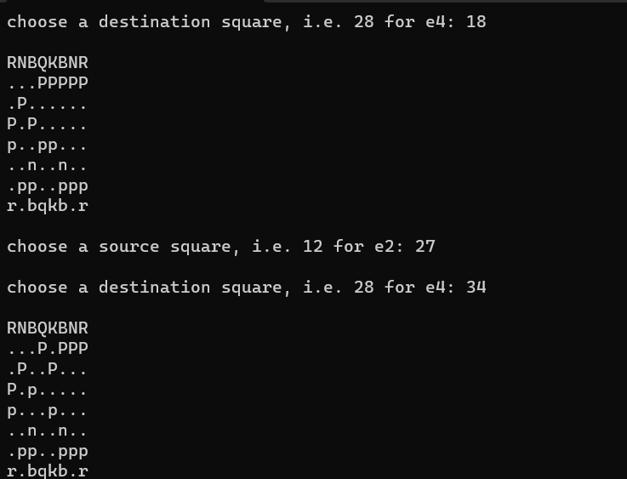

Go through minmax function and figure out why it didn’t take back

